Introduction
This document outlines the Refinance/Reinstate flow from the Broker side. The client-side Refinance/Reinstate functionality has already been developed.
Point #1
Add a Reinstate button. This button should only appear when the loan is eligible for reinstatement. Additionally, user access must be controlled through permissions — the FCIF Admin should assign the appropriate user role to show this button.
Referenced Screenshot

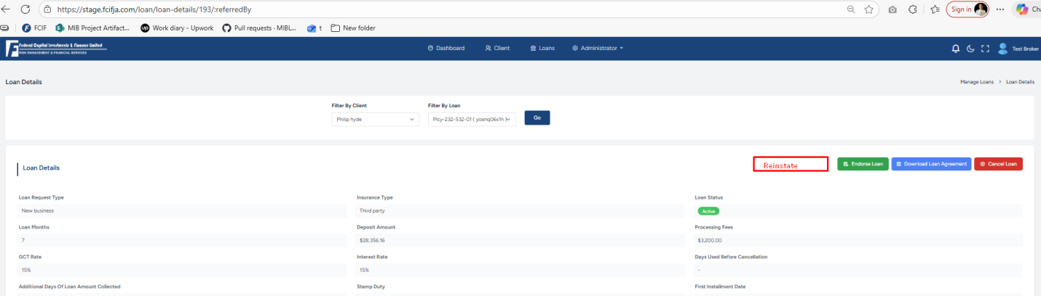
Point #2,
Refinancing Validations
The refinancing validations must be identical to those in the client portal.

Refinancing Limits:
- Refinancing is allowed only up to one (1) month before the policy expiration date.
- Example: If a policy has 6 months remaining until expiry, the system will recalculate the premium using a maximum tenure of 5 months.
- Refinancing will take maximum tenure by default broker cannot minimized the tenure of loan.
Pre-Conditions for Starting the Refinancing Process:
The system must not initiate the refinancing process unless:
- All late fees are paid.
- The reinstatement fee is paid.
(smilar to Cleint platform)
For online payments, the amount will be deposited directly into the FCIF account.
If the broker is MIB, cash payments will also be deposited directly into the FCIF account. Because MIB shared with same cashier.

Process Reinstate:
After the reinstatement fee and late payment fee are collected, the FCIF Broker’s platform will generate the new financed policy. This process is similar to creating a new loan application but uses special refinancing ID codes and calculations are based on the Refinanced Interest Matrix. This process to similar to Client Portal.

