Introduction
This document outlines the fixes needed to address the screen flickering issue during loading, and implantation of normal user experience.

Detail
Point # 1, Screen is flickering while loading operation.
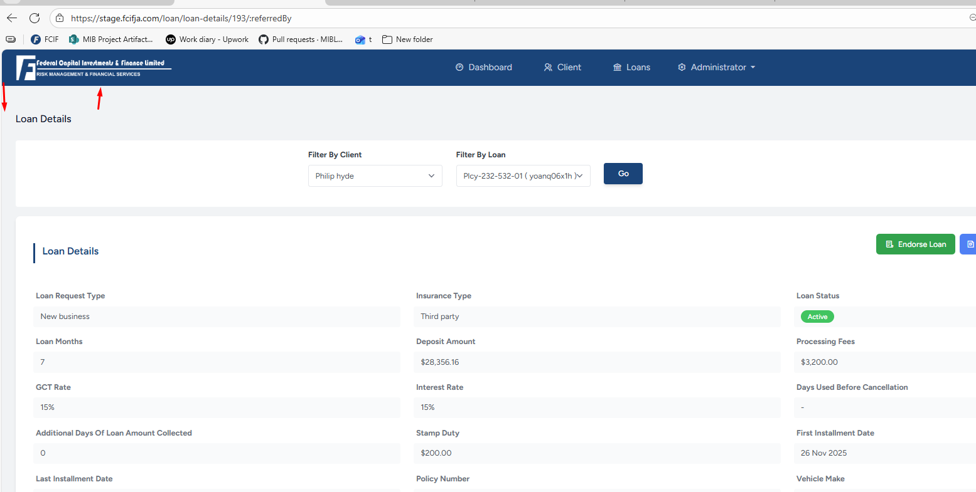
Point # 2.
During the payment process, once the payment is captured and the success message is displayed, the screen briefly disappears and reloads. As a result, the user must scroll down and return to the same tab to download the receipt.
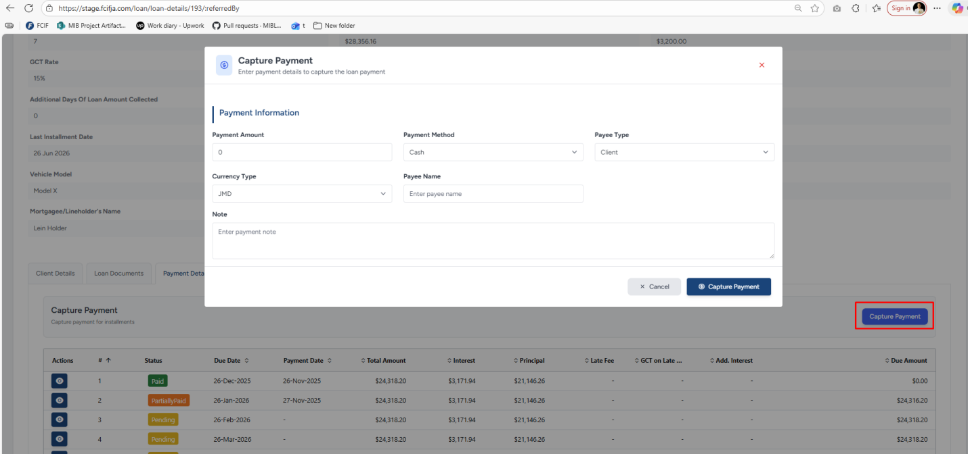
Payment process
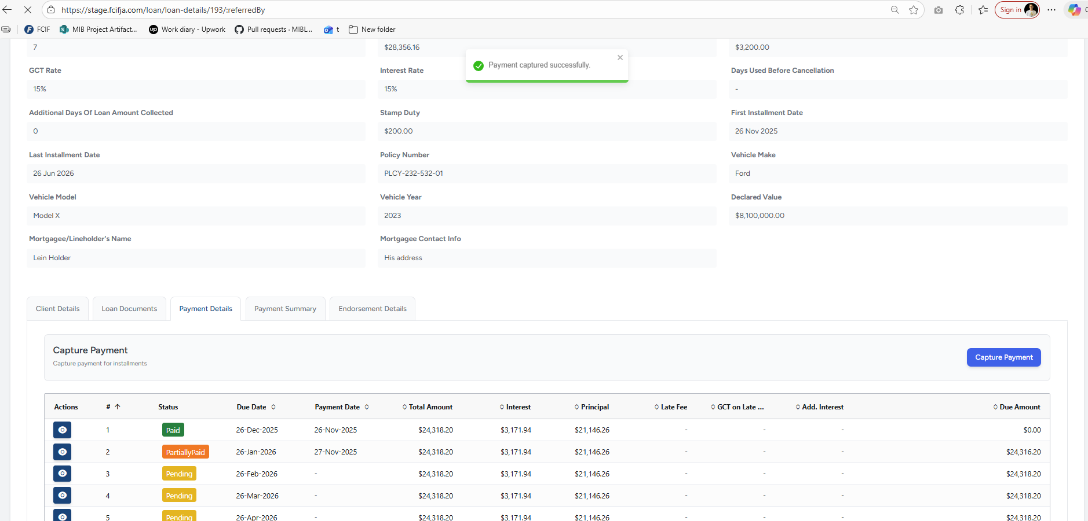
Success Message
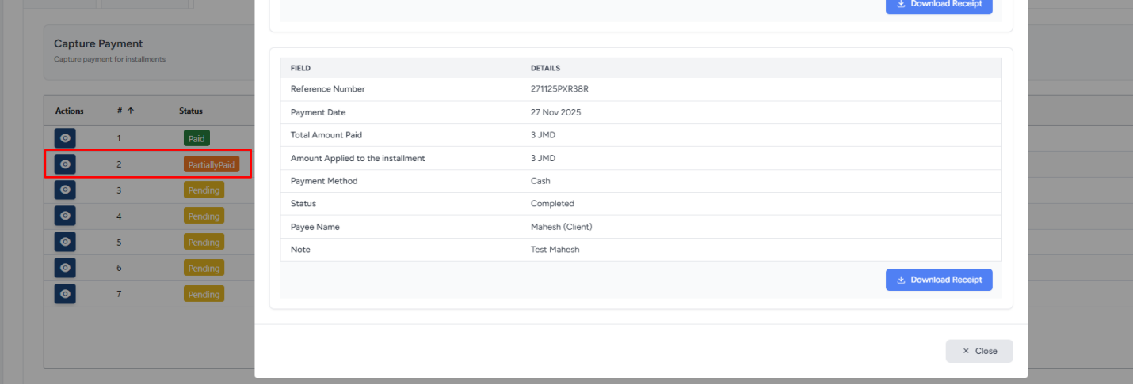
User have to perform Acton to come back on payment tab

Expected Flow:
The user will use this screen extensively, so it should be optimized.
- The screen must maintain its position after payment operations.
- The most recent entry should appear at the top.
- After a successful payment, the system should prompt the user to download the receipt. This will save time and ensure smoother operations.

Reference screen shots are below:

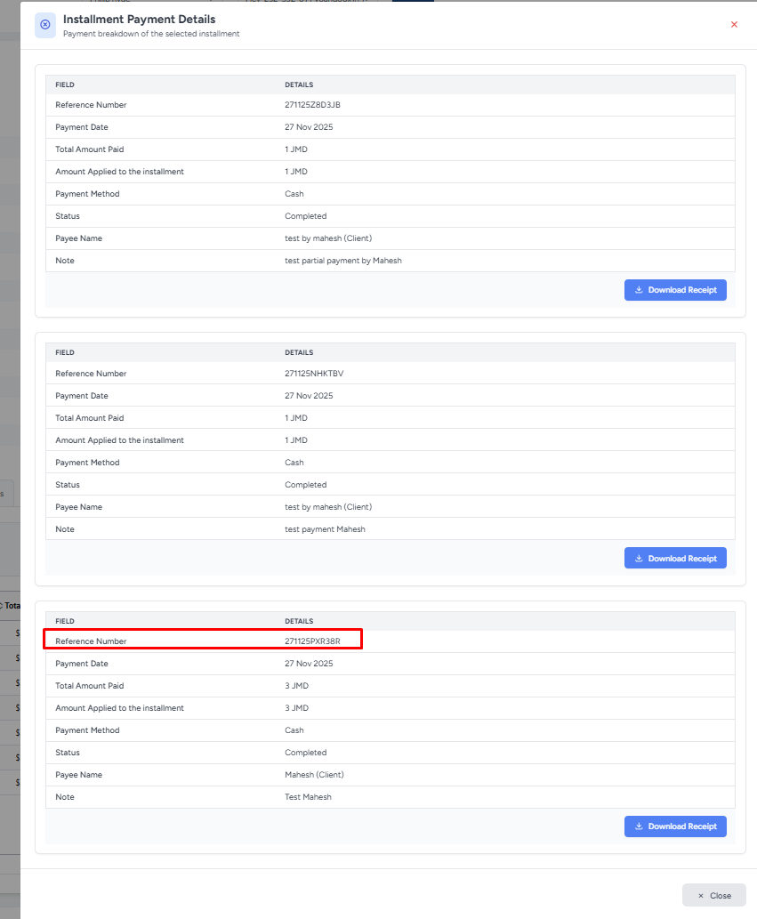
Most Recent Transaction should come on top
Here is a refined version of your text:
The recent transactions are not sorted correctly. I added a $3.00 transaction most recently, but even after applying the sort, it still does not appear at the top.
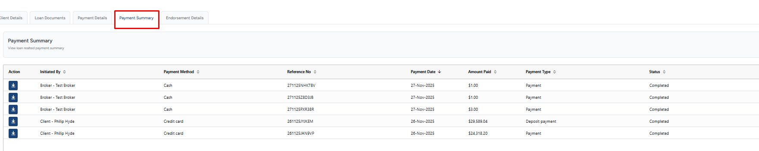
Payment under not sorted

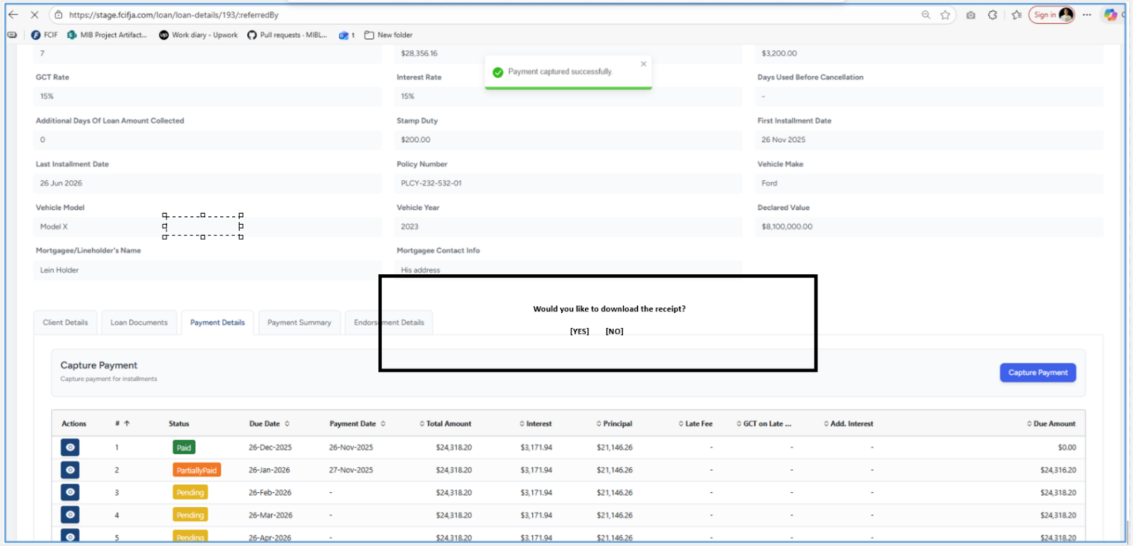
Suggested prompt for download receipt

