Introduction,
This document is suggesting the how system reverse the late fee, with using current developed screens.
Current screen is below:
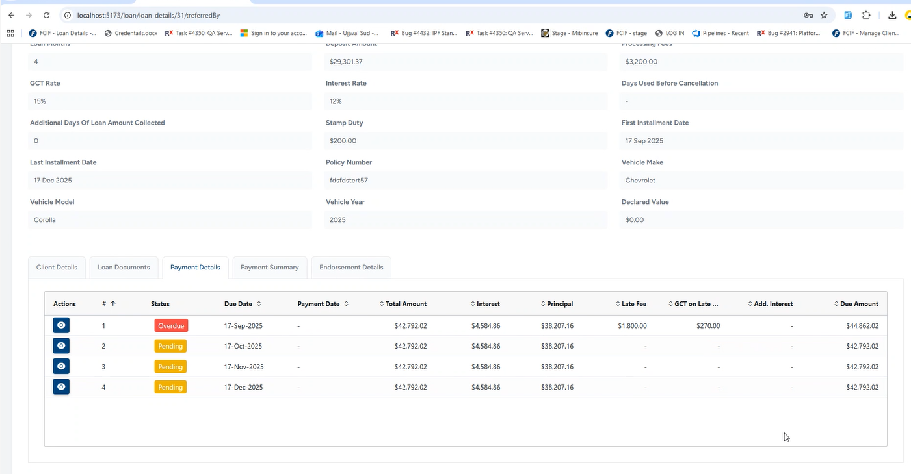

Reversal of late fee
Validations before reversal,
1) Fee should not be paid,
2) User must have to Role & permission to use Reversal.
Suggested Screen Flow
Introduce a new action button to allow reversal or waiver of fees. This button should only be visible to users who have the appropriate access rights; all other users should not see it.

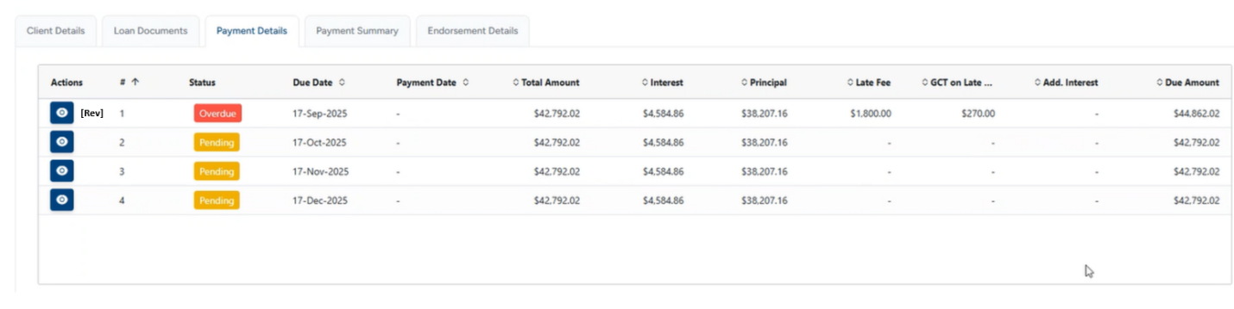
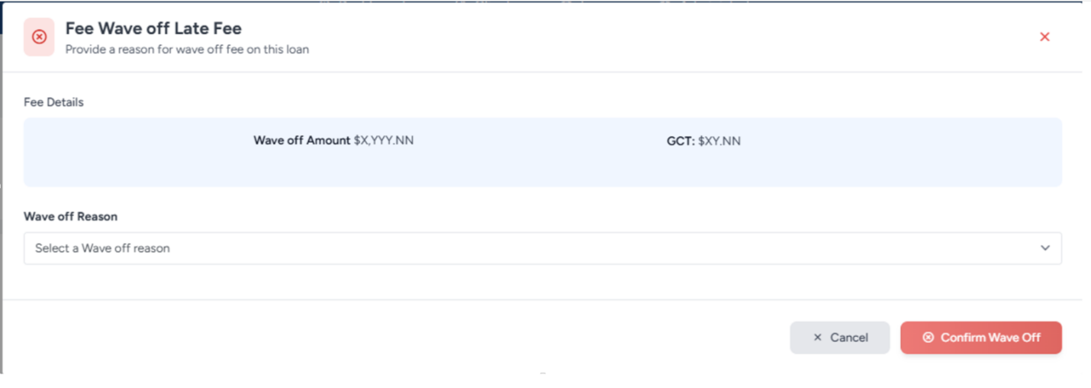
After the waiver, the loan balance will be recalculated, and the late fee entry will be removed. However, the payment history must still display the reversal details, including the date, amount, the user who processed the waiver, and any related reason.

Entires into EPCI
