Disbursement FLOW
Introduction
This document provides a comparison between the legacy FCIF system and the new system in the context of the disbursement flow. The objective is to ensure that the new system functions correctly and does not overlook any existing business processes.

New Workflow
Screen 1: Disbursement Cut-Off Date Setup
FCIF users can configure the disbursement cut-off date, which operates on a monthly basis. For example, a user can define a specific day (X) of each month as the cut-off.
In the future, this date can also be used for automated reminders—for instance, the MIB team can be notified Y days before the cut-off date.

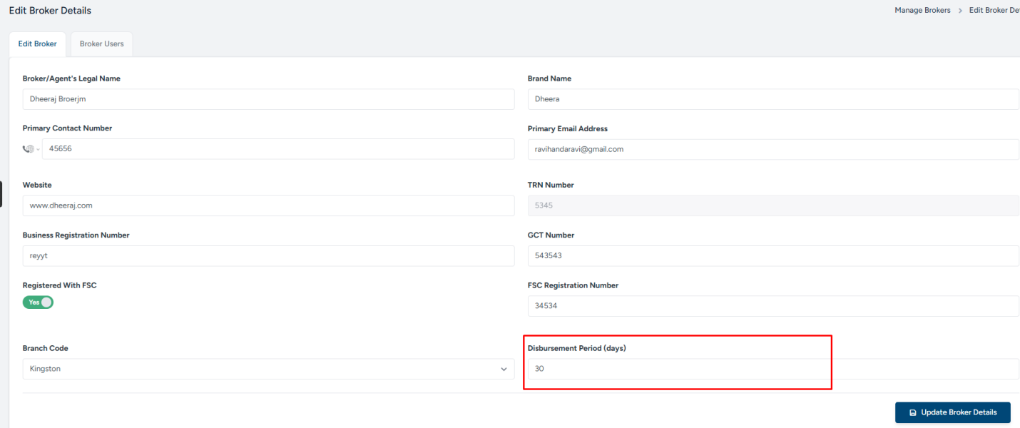
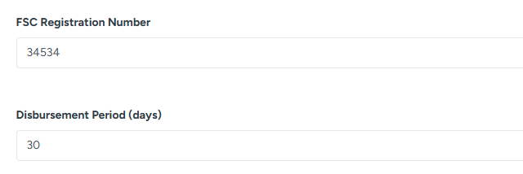

Screen 2: Disbursement Filtering and Selection
The user can filter disbursements by Broker, and all clients associated with the selected broker will appear in the grid. The user will then select the loans to be disbursed.
LPI is requested to add the following information when the user performs actions on this screen:
a) Count of selected loans
b) Total amount of selected loans
c) Broker’s cut-off date – This is critical information for the disbursement process and should be automatically populated when the user selects the broker.
d) Client’s EPIC Code – Add a new column in the grid to display the EPIC Code for each client.
e) Instead of Loan Amount LPI is requested to Add Principal and Interest.
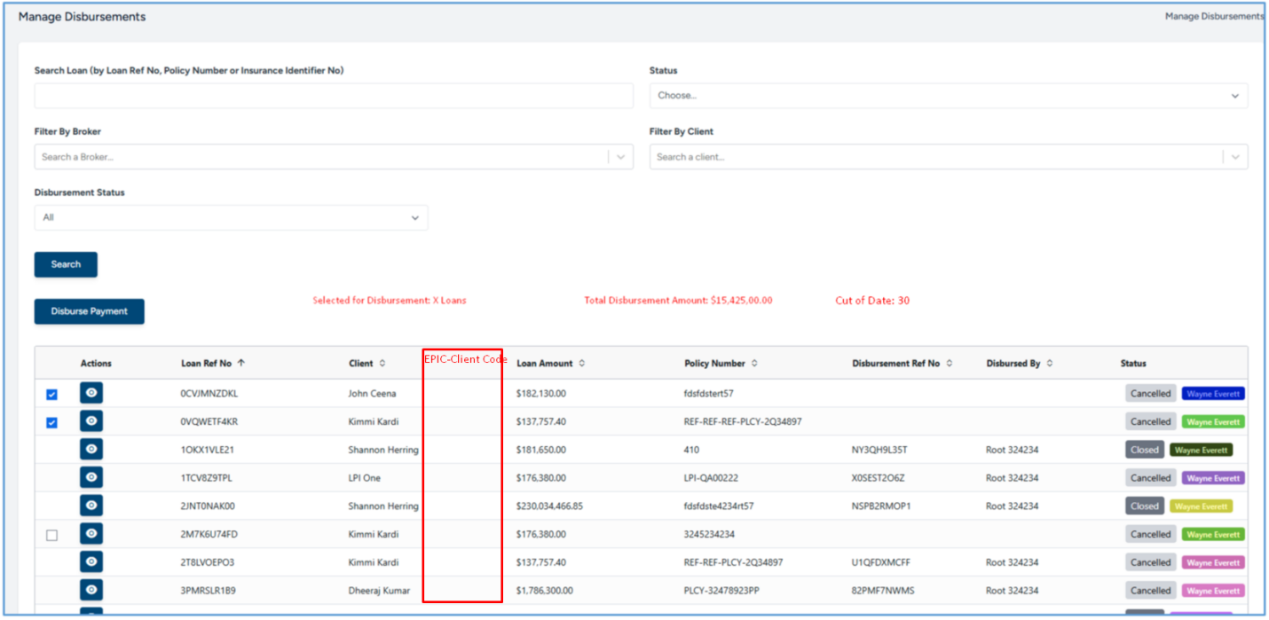

Screen 3: User will add the Disbursement Details,
User will add
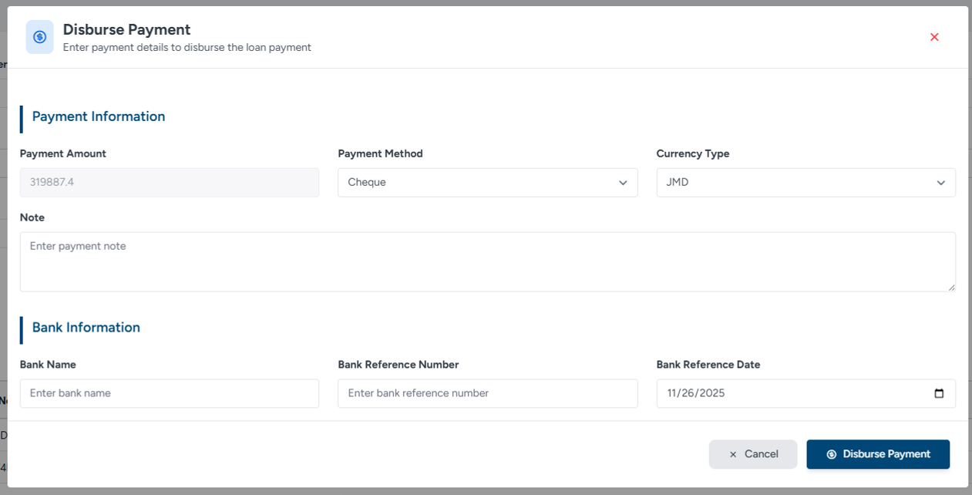

Screen 4: How to see the Disbursement history?
User have to selected the status “Disbursed” status then
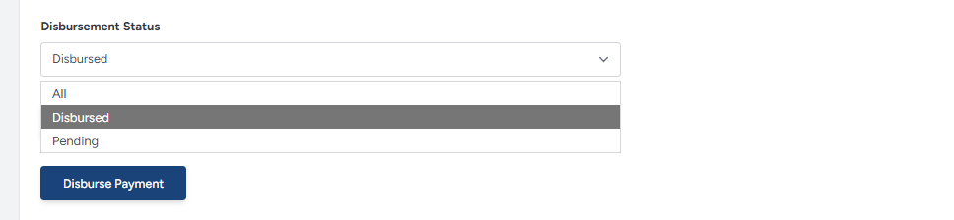
System will fill the gird with Disbursed Values,
LPI is requested to Add the Disbursed Date ( Date when Disbursement made by user) . Column it is required to tally with Bank system.

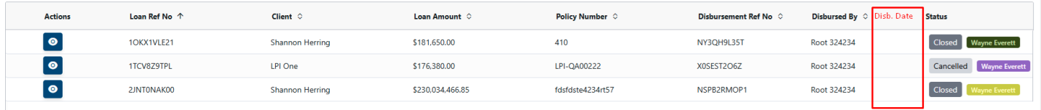

Explanation of Disbursement Amount:
What is the Loan Amount?
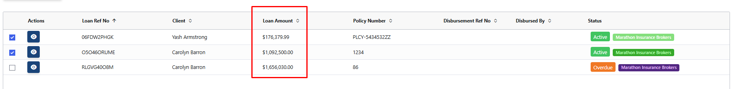
Selected first loan for details
Get the one loan

Below is the payment details.
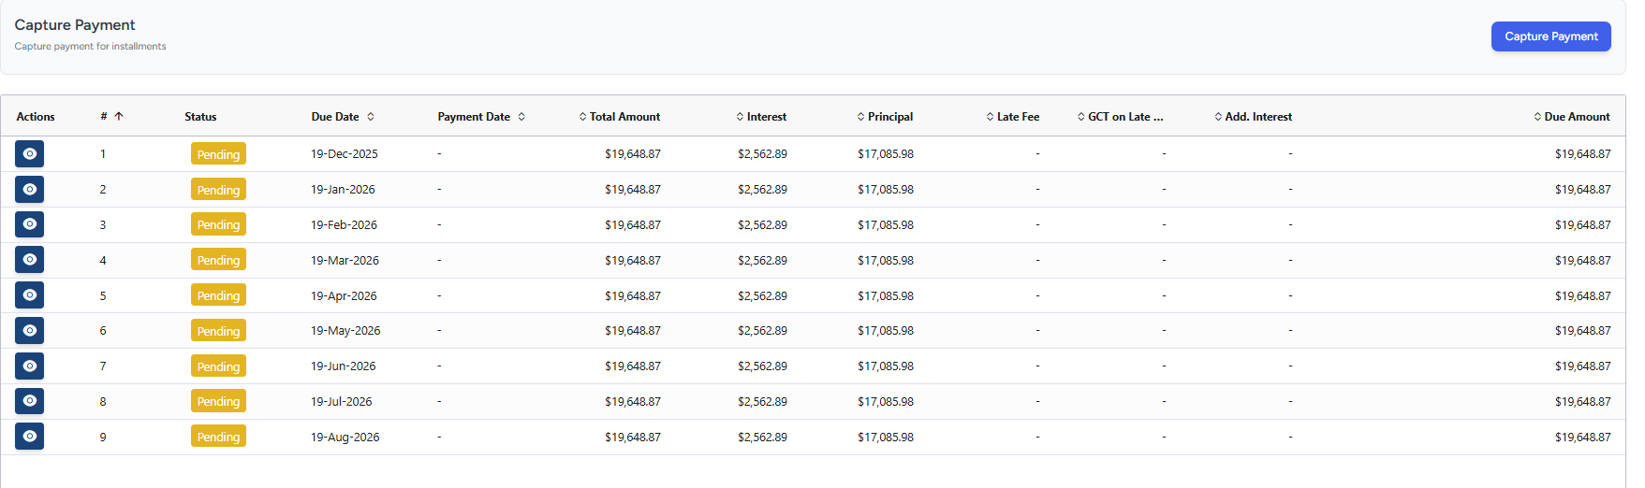
When I total the principal I am getting $153,773.82
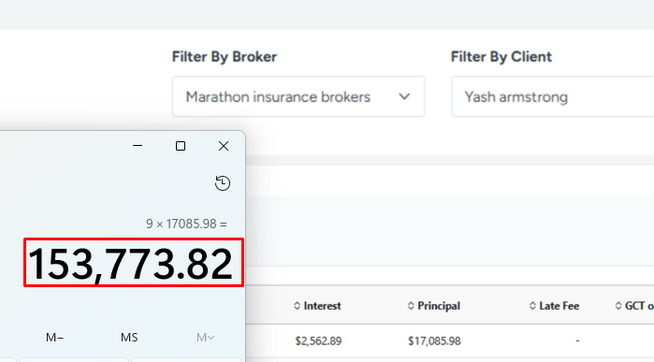
I confirmed from Mr. Ujjwal that what is loan Amount, he answered it is Amount Financed, ( Premium + GCT).

Point Need to confirm
As I FCIF needs to disburse the Amount Financed,
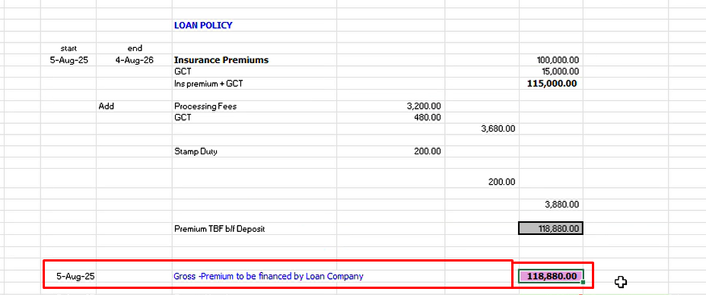
Currently LPI is disbursing the 176.979.99 LPI Need correct the calculations and before UAT provide the disbursement calculations in excel. 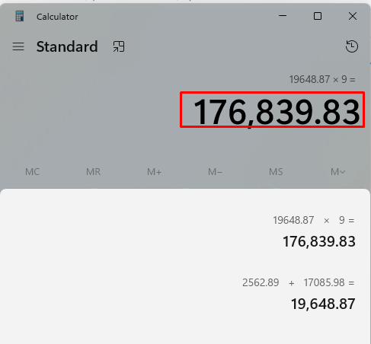

Actions from LPIs
1. Changes on screens.
2. Calculation changes based on MIB Response and provide the details how calculation implemented.

EPIC Migration,
J/E done by Manually in EPIC

