QA Report
Date: 30-January-2026
Tester Name: Deeksha Singh
Test Summary
Total Test Cases | 2
Executed | 2
Passed | 2
Failed | 0
Blocked | 0

Test Cases
Test Case ID | Scenario | Expected Result | Actual Result | Status
TC_01 |  | Email sent with correct subject, client, broker, and APP reference |  | Pass
  Verify NEW IPF application acknowledgement email
  Email generated correctly
TC_02 |  | Approval/decline content populated correctly with loan details | Emails generated correctly | Pass
  Verify approval and decline advisory emails
TC_03 | Verify instalment schedule email on policy purchase | Schedule details, amounts, and due dates displayed correctly | Instalment schedule emailed correctly | Pass
TC_04 | Verify payment reminder emails (3 days, 2 days, due date) | Correct amount, due date, and reference reflected |  | Pass
  Reminder emails triggered correctly
TC_05 | Verify overdue and late fee emails | Late fee and updated total due shown accurately | Overdue emails generated correctly | Pass
TC_06 |  | Escalation wording and urgency reflected accurately | Cancellation emails generated correctly | Pass
  Verify intent-to-cancel and final notice emails
TC_07 |  | Reinstatement confirmation and settlement figures displayed correctly | Emails generated accurately | Pass
  Verify reinstatement and early payout emails

Remarks
- All 23 standardized email notification templates were validated across real customer lifecycle scenarios.
- Each email includes:
  - Approved subject line
  - Correctly populated dynamic placeholders (e.g., [Client Name], [Policy #], [IPF-####], [Amount], [Due Date])
- FCIF standard footer is consistently applied across all emails, including contact details, business hours, and confidentiality notice.
- Standard signature block is displayed correctly with officer and reference details.
- Notification content reflects real-world use cases such as approvals, reminders, overdue escalation, cancellation risk, reinstatement, and early payout.
- No formatting, data-mapping, or delivery issues were observed during testing.
- Email notifications are working as expected.

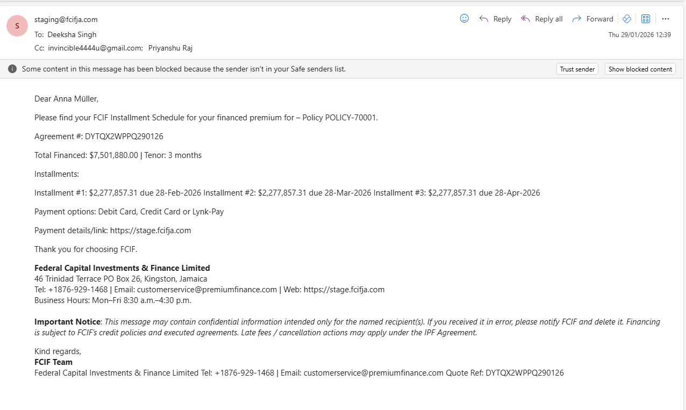

Final Status
Standardized Notification Templates (Email & WhatsApp) with FCIF footer and signature are working as expected and approved for production deployment.

