QA Report
Date: 30-January-2026
Tester Name: Deeksha Singh
Test Summary
Total Test Cases | 3
Executed | 3
Passed | 3
Failed | 0
Blocked | 0

Test Cases
Test Case ID | Scenario | Expected Result | Actual Result | Status
TC_01 |  | System should generate approval advisory email on Loan Approval |  | Pass
  Trigger Approval Advisory on IPF approval
  Email triggered successfully
TC_02 |  | Subject, body, and financial details should match approved template | Content populated correctly | Pass
  Verify email content and placeholders
TC_03 | Verify email delivery to configured recipients | Email should be received by Client, Broker, and Insurer | Email received by all recipients | Pass

Remarks
- Approval Advisory email is generated automatically by the FCIF system upon IPF application approval.
- Email subject follows the standard format:
“FCIF Approval – IPF Application Approved | [Client Name] | [IPF-####]”.
- Email body correctly displays:
  - Client name
  - Policy / Quote reference
  - Approved amount
  - Tenor
  - Deposit / Down payment
  - First instalment due date
- Standard FCIF footer and signature block are applied consistently.
- Notification settings validated:
  - Group: Client
  - Sub-Group: NEW
  - Reason: Approval Advisory
  - Type: System-generated response
  - Recipients: Broker, Client, Insurer
  - Frequency: Triggered automatically on Day 1
- Email delivery confirmed via system preview and recipient inbox.
- Approval Advisory email is working as expected and is being received successfully.
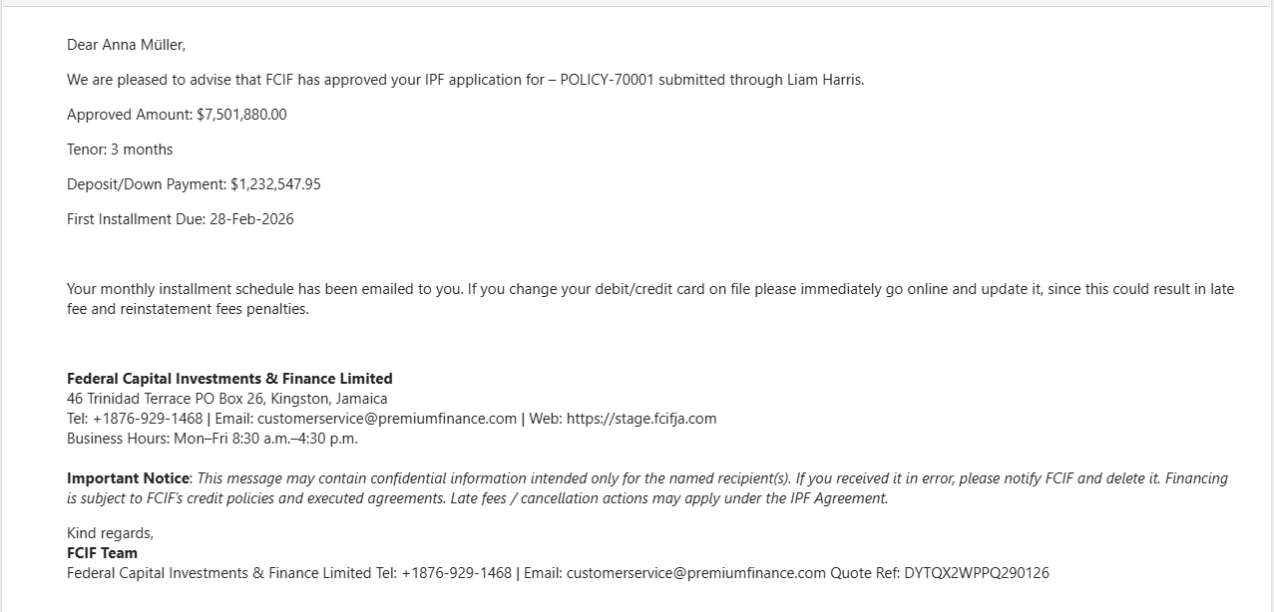

Final Status
NEW – Approval Advisory email notification is working as expected and emails are being received successfully. Approved for production deployment.

