Redmine #4860

A. Instalment Due Date Update
- Identify the nearest pending instalment for the current loan.
- Update the installment due date accordingly in the “LoanInstallmentDetails” table “Due Date” Column.
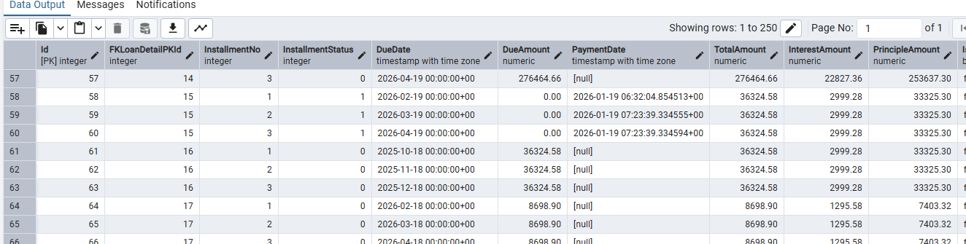
B. Job Execution
- Navigate to the Jobs section.
- Manually trigger the recurring job service responsible for installment payments.
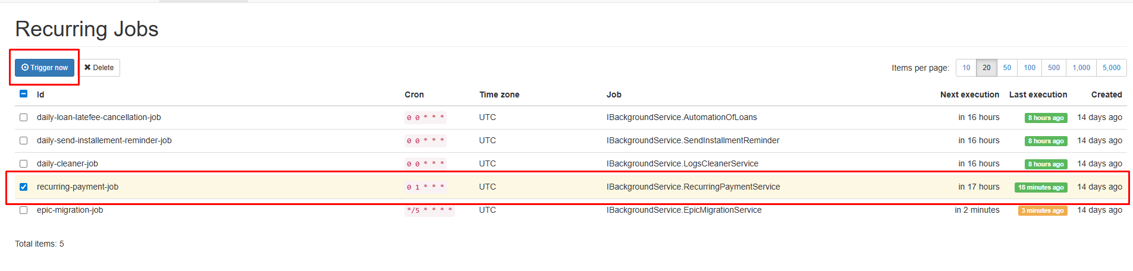
C. Payment Prerequisites
- Client must have:
  - At least one saved card available in their account.
- If multiple cards exist:
  - The default card is selected automatically for payment processing.
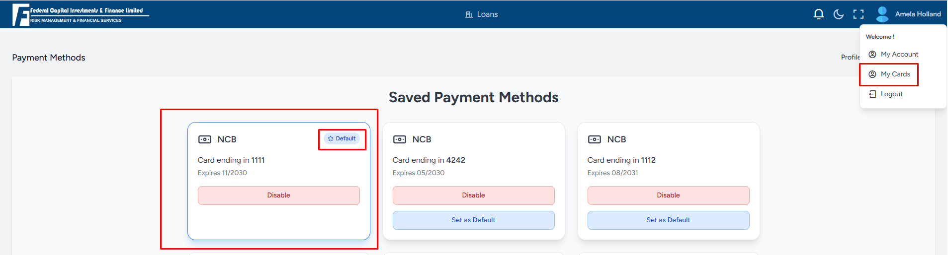
D. Automated Payment Processing
- System attempts payment using the default saved card.
- Payment is processed only if:
  - The card has sufficient balance / limit.
- On successful payment:
  - Installment payment is completed.
  - Loan balances and installment status are updated.
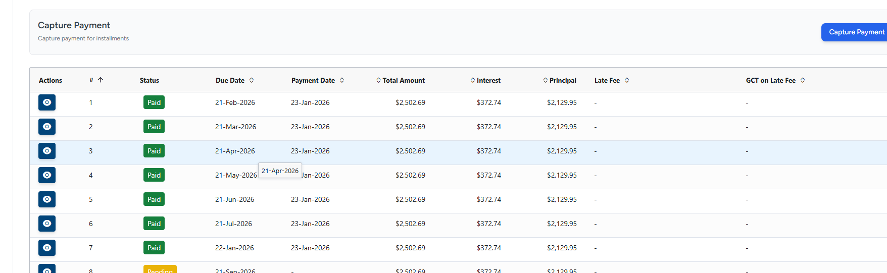

E. Error Handling, Retry, and Penalty Flow
- If any error occurs during payment (for example: insufficient funds, card error):
  - Payment is not failed permanently.
  - The payment attempt is automatically retried on the next execution date.
- If payment continues to fail:
  - The system keeps retrying the payment on subsequent execution dates.
  - After 3 days, late fees are applied automatically.
  - After 11 days, if payment is still not successful, the loan is automatically cancelled.
Summary
- Recurring job correctly processes installment payments.
- Default saved card is used automatically.
- Successful payments update loan balances correctly.
- Failed payments are safely rescheduled without manual intervention.

Status: Tested and Verified

