Redmine #4835 – Late Fees

A. Loan Creation
- A new loan was00 created successfully.
- System generates a Loan ID, which is mandatory for further processing.
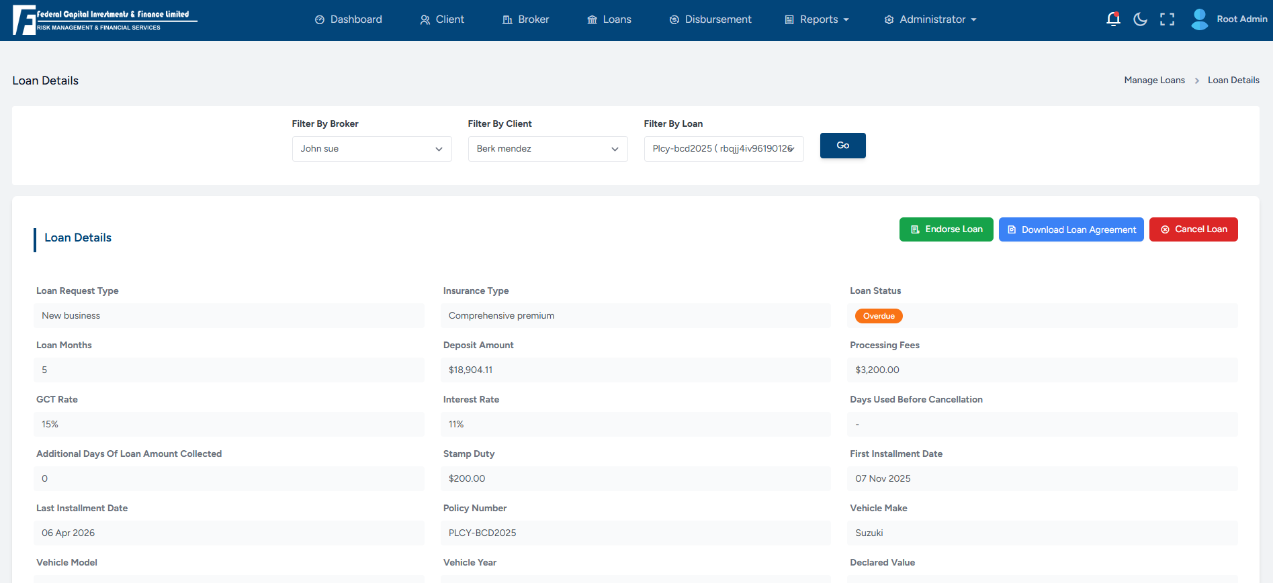

B. Due Date Modification
- The loan Installment Due Date is updated to a date:
  - Greater than 3 days, and
  - Not more than 10 days from the Installment Due Date.
- This update is performed directly from the Database (DB).
- The Due Date is updated using the Installment ID in the “LoanInstallmentDetails” table.

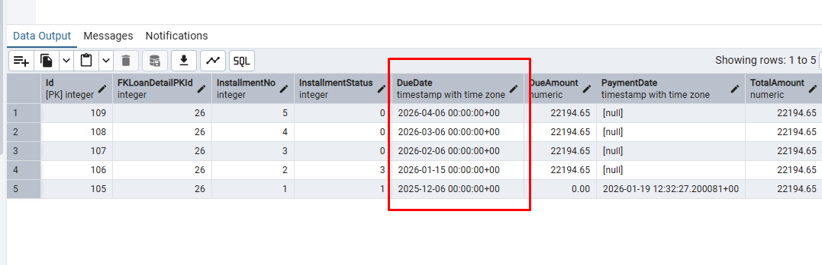

C. Late Fee Job Execution
- The scheduled job “daily-loan-late-cancellation-job" is manually triggered from:
  - jobs/recurring
- Once the job runs successfully:
  - Late fees are automatically applied to the loan based on the updated due date.
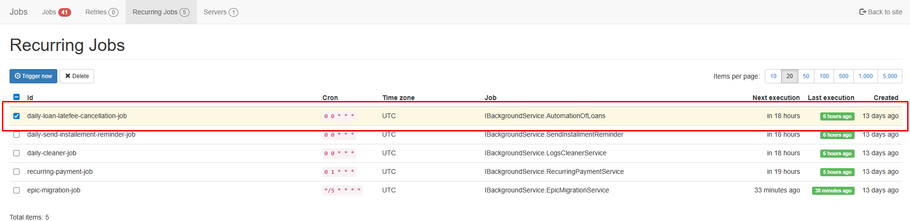

D. Late Fee Application
- After the job execution:
  - Late fee is reflected against the loan.
  - Loan status and payable amount are updated accordingly.
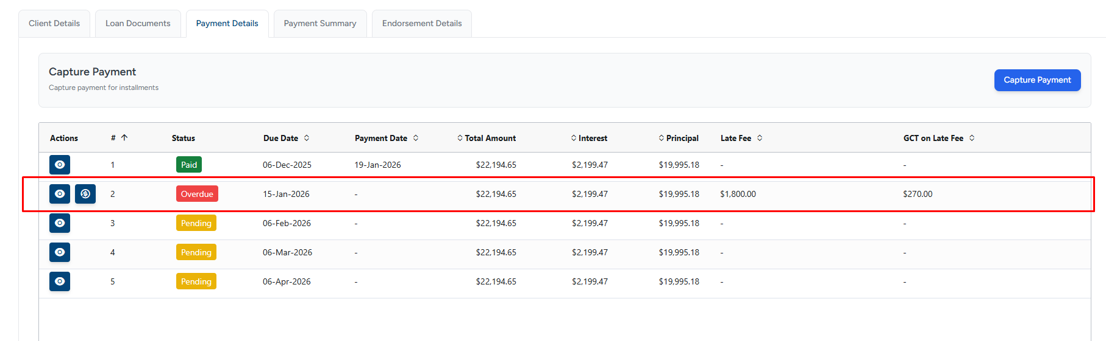

E. Late Fee Wave-Off (UI Flow)

1. Visibility of Wave-Off Option
- Once late fees are applied:
  - A “Wave Off” button becomes visible on the UI.
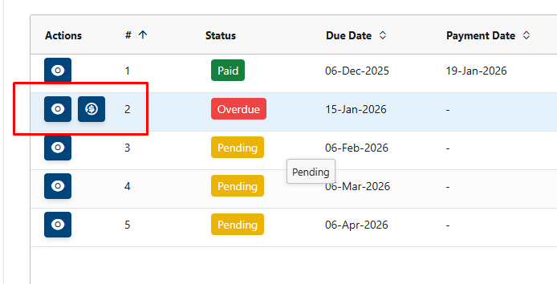

2. Wave-Off Action
- User clicks on Wave Off.
- User selects a reason for waving off the late fee.
- User clicks on Confirm Wave Off.

3. Result
- Late fee is successfully waived.
- Updated loan amount is reflected correctly on the UI.
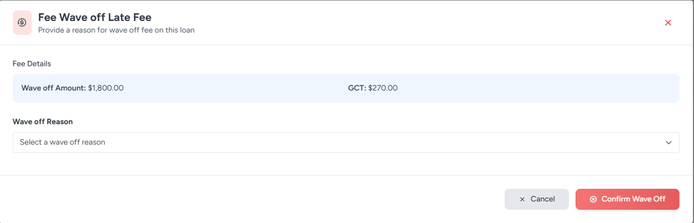

Summary
- Late fees are applied correctly when the due date exceeds the allowed threshold.
- Scheduled job execution works as expected.
- Wave-off functionality is available only after late fee application.
- Reason selection and confirmation flow works correctly on the UI.

Status: Tested and Verified

  - Jobs URL and Credentials
Link: https://stageapi.fcifja.com/jobs
User: Admin
Password: S3(r3tP@55w0rd

  - Database PostGresql
Server: 44.237.228.238
Username: postgres
Password: Admin123

