Redmine #4844 – Loan Refinance
A. Loan Cancellation
- Once the loan is cancelled:
  - The Refinance button becomes visible on the Loan Detail page.
  - This button is available on both:
    - Broker side
    - Client side
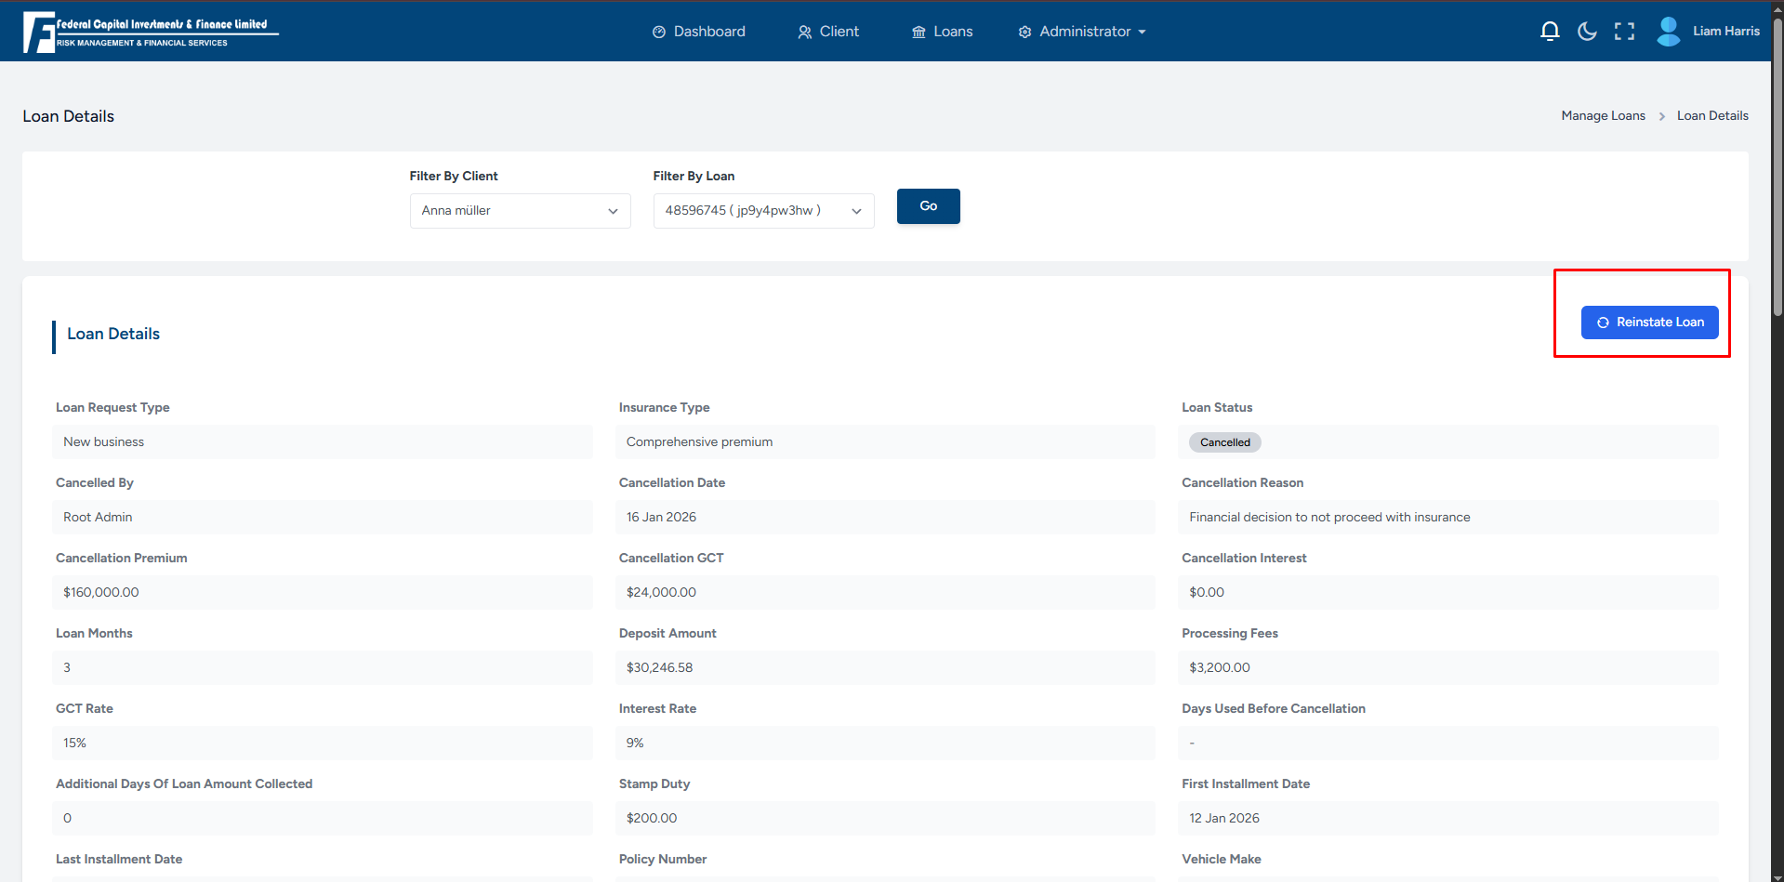
B. Refinance Calculation
- User clicks on the Refinance button.
- User won't be able to change no. of instalments
- User selects:
  - Deposit Amount
  - First Installment Amount
- User clicks on Calculate.
- System successfully calculates the refinance details.
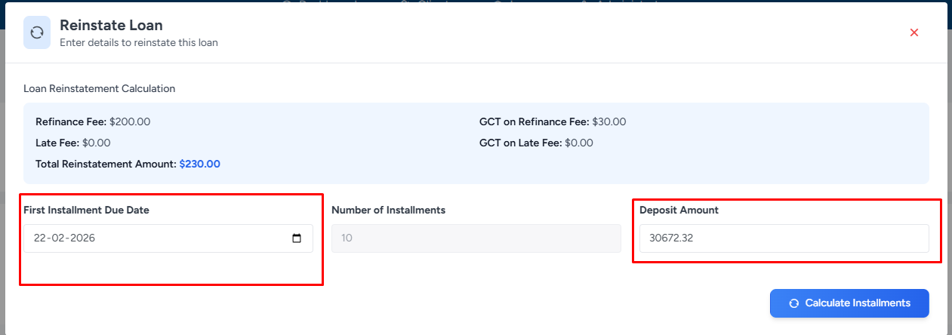

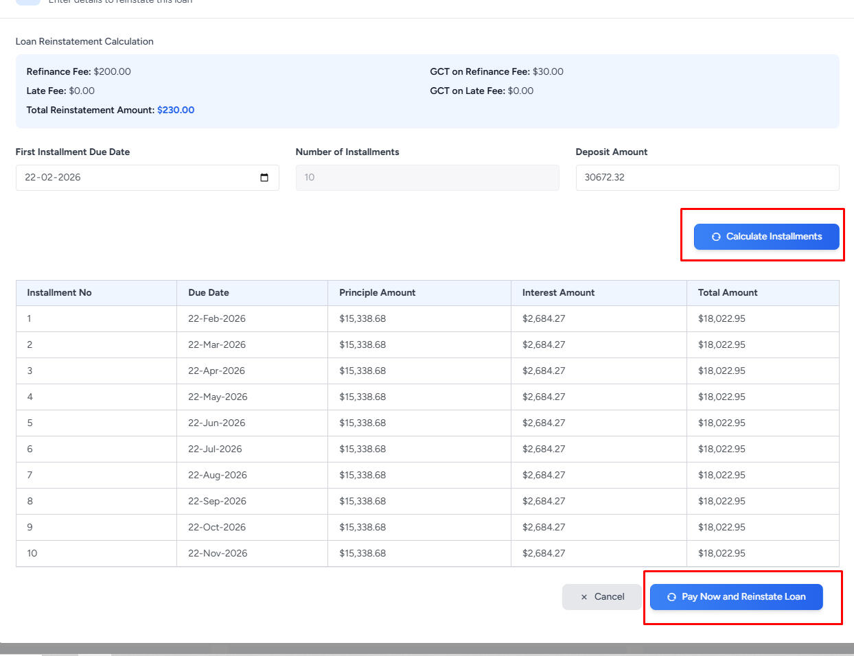

C. Payment Capture (Pay Now)
- User clicks on Pay Now.
- Payment amount is entered with the following validation:
  - Entered amount must be equal to or greater than the calculated payment amount.
  - Amount cannot be less than the required payment amount.
- User clicks on Capture Payment.
- Payment is captured successfully.
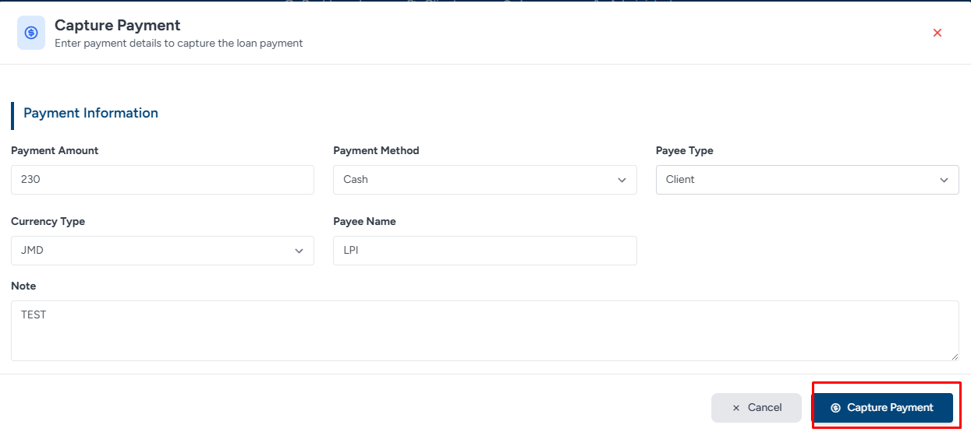
D. Post-Refinance Validation
- Once the refinance process is completed:
  - The Refinance button disappears from the Loan Detail page.
  - A new loan is created automatically based on the refinance details.
  - New Loan ID is generated and displayed correctly.
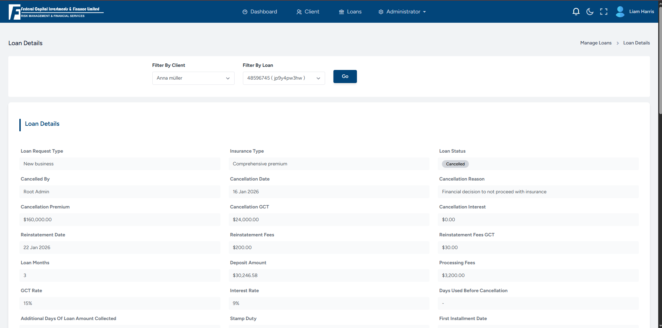
The prefix “REF” will be added to the refinanced loan

Summary
- Refinance option appears only after loan cancellation.
- Calculation and payment capture flow works as expected.
- Refinance button is removed after successful refinance.
- New loan is created correctly with updated details.

Status: Tested and Verified

